**1. INTRODUCTION**

**1.1 Overview**

In 1996, the first electric vehicle was a three-wheeler, invented by Scooter’s India Pvt Ltd, and it was named VIKRAM SAFA. Approximately 400 vehicles were made and sold. In 2000, BHEL developed an eighteen-seater electric bus, which became popular too. Then approx. 200 electric vans were made and ran in Delhi. But it did not do that well in the market as it required a high cost for the battery and its low life. Electric vehicles came into existence in the 19th century. Earlier, they did not do that well in the market because of its high cost, low speed, and short-range. So initially, the demand declined worldwide. However, they have been used for transportation and public transport, especially as rail vehicles. As the concern for the environment increased in the 21st century, gas-powered vehicles emit a lot of smoke and are incredibly harmful to the atmosphere.

Therefore, the interest in electric vehicles increased too. Electric cars were popular among those who used them in the city where their short-range did not prove a disadvantage. Another reason that gave it a boom was that there was no requirement to change the gears, making it an easy option. It did not have vibration sounds or any sound. It did not require a manual start, which was also a plus point. Due to a lack of power infrastructure, acceptance of electric vehicles was hampered. In a bid to overcome the limited operating range of electric vehicles and the lack of recharging infrastructure, an exchangeable battery service was first proposed in 1896.In 2007, Hero cycles, in partnership with UK-based ULTRA Motor, launched a series of bikes. These electric bikes became popular among other companies named Electrotherm India, TVS Motor, Hero electric, etc. They are also manufacturing and selling their products. Furthermore, in 2017 Etrio raised over 3 million in funds from HNIs and set out to transform existing fuel-powered commercial vehicles into electric variants, thus benchmarking efficient and eco-friendly transportation.

**1.2 Purpose**

In this project we analysis that charging stations in India, charging stations by region and its types, different types of EV cars in India, top speed and price of EV cars by different brands and etc. In real life Electric vehicles use electricity to charge their batteries instead of using fossil fuels like petrol or diesel. Electric vehicles are more efficient, and that combined with the electricity cost means that charging an electric vehicle is cheaper than filling petrol or diesel for your travel requirements. Using renewable energy sources can make the use of electric vehicles more eco-friendly. The electricity cost can be reduced further if charging is done with the help of renewable energy sources installed at home, such as solar panels.

**2. PROBLEM DEFINITION & DESIGN THINKING**

**2.1 Empathy Map**

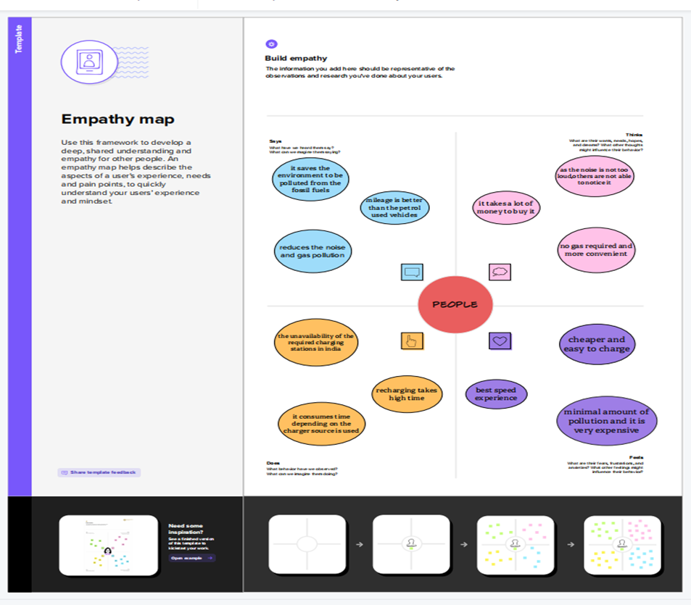

**2.2 Ideation & Brainstorming Map**



**3.RESULT**

**Dashboard:**

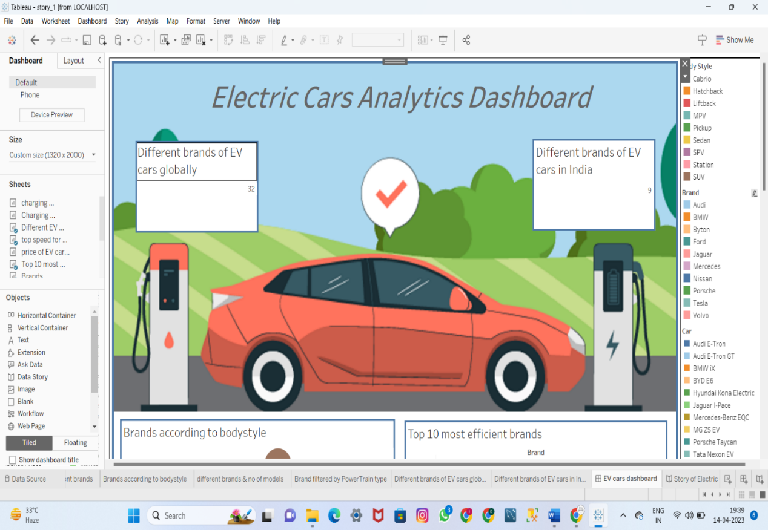

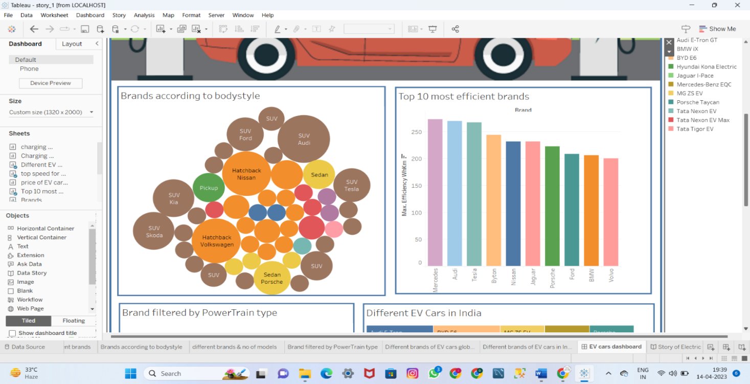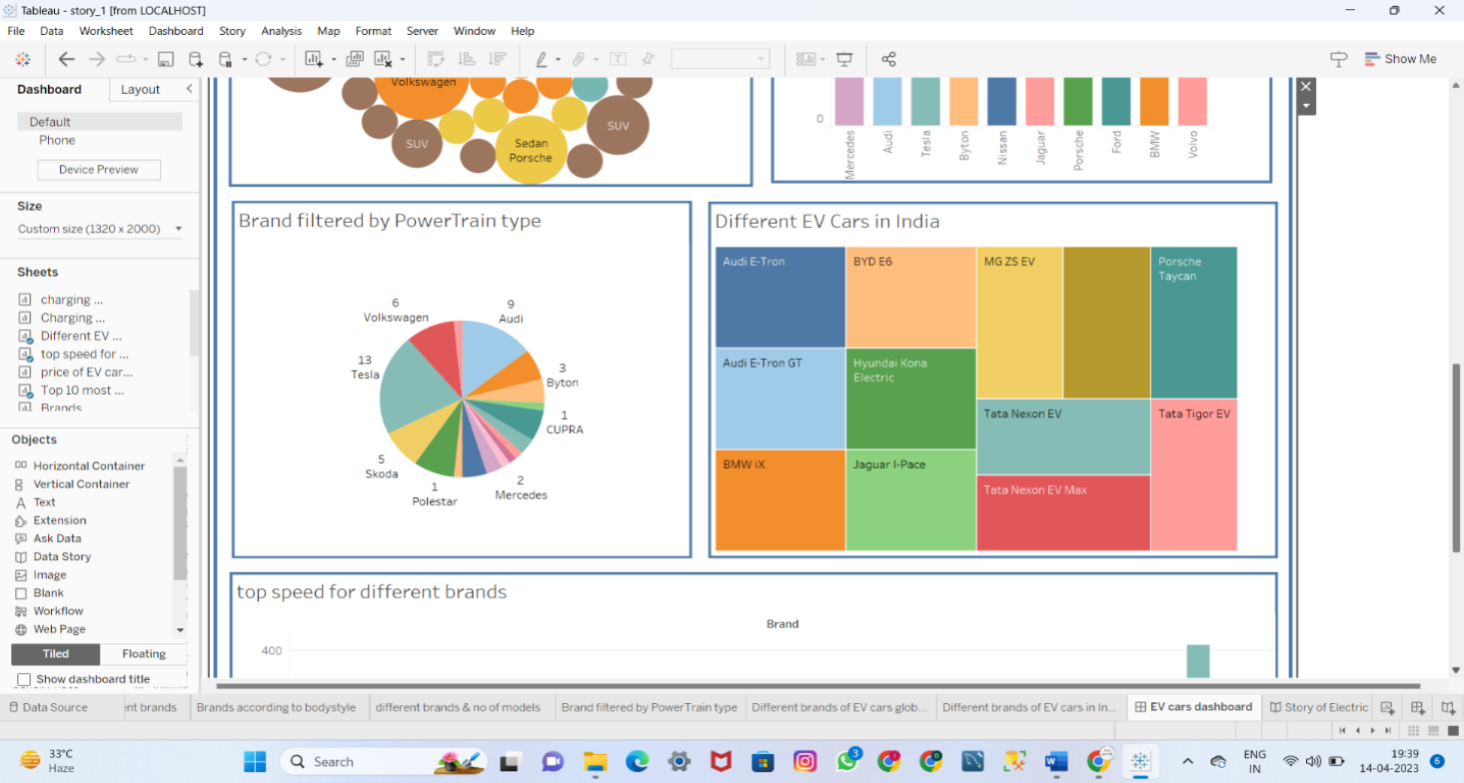

**Story:**



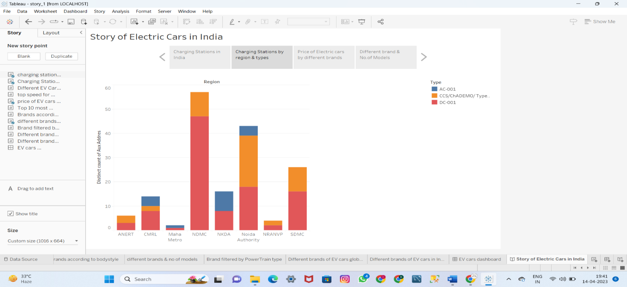

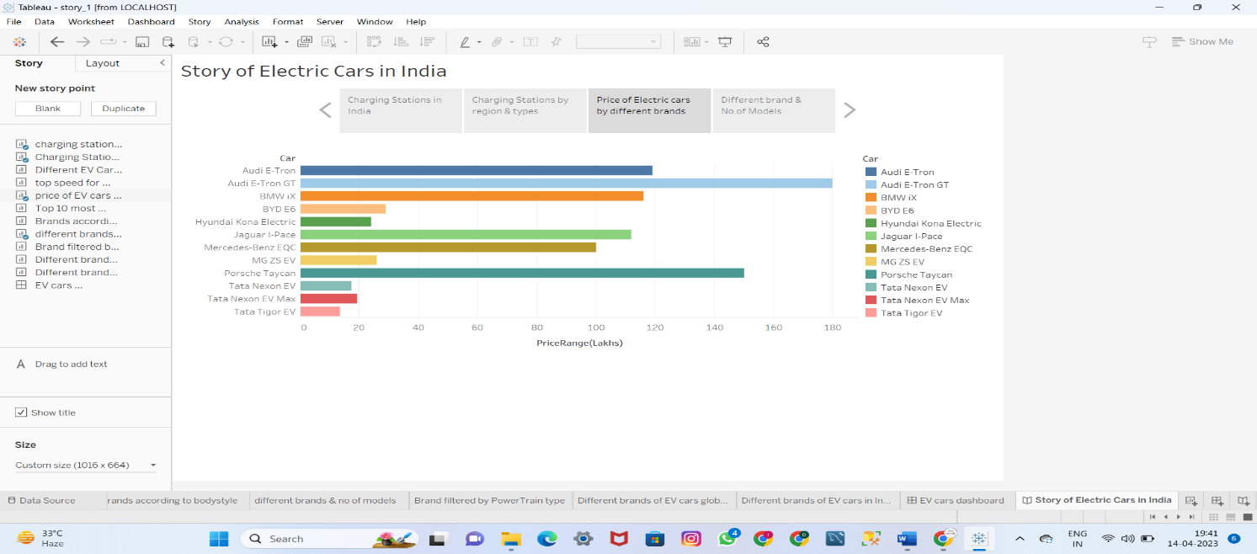

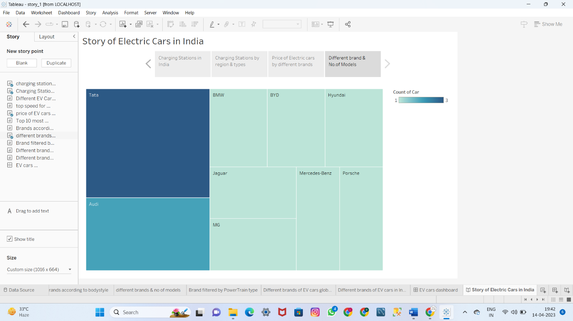

**Web Application:**

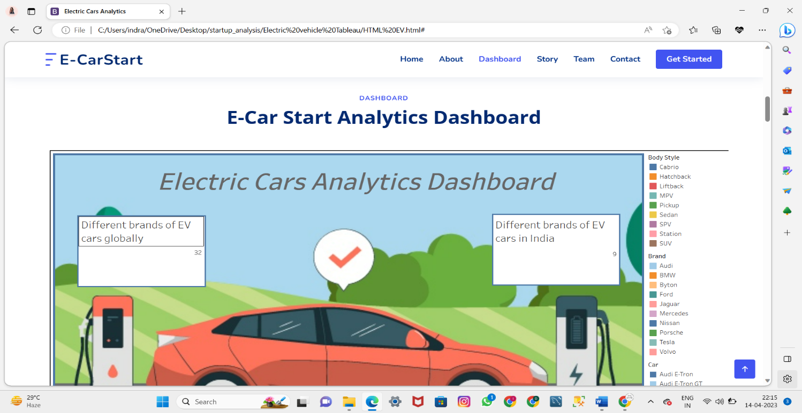

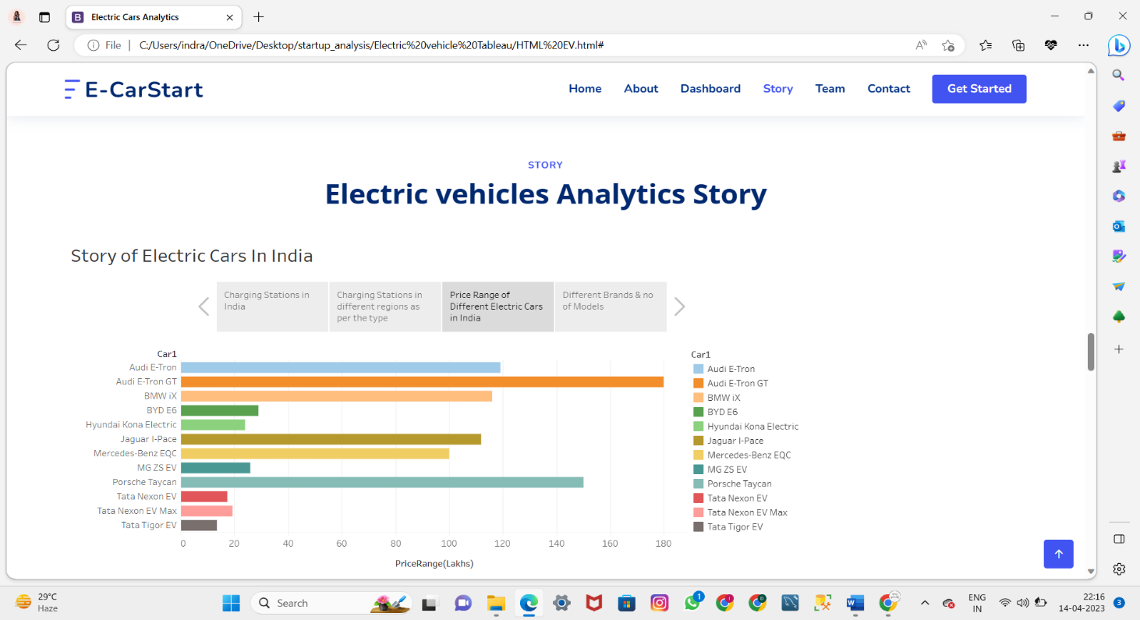

**4. ADVANTAGES & DISADVANTAGE**

**Advantages:**

* One of the best advantages of using the EV is it saves the environment to be polluted from the fossil fuels. With the increase in the population and their desires which is causing global warming can be reduced with the EV.
* More Convenient.
* Cheaper and easy to charge.
* Best speed experience.

**Disadvantages:**

* It consumes time depending on the charger source is used.
* The unavailability of the required charging stations in India.
* It’s expensive.
* Minimal amount of pollution.

**5. APPLICATIONS**

Personal transportation: EVs are becoming increasingly popular as an alternative to gasoline-powered cars for personal transportation.

Fleet transportation: Many government agencies and companies are incorporating EVs into their fleets for more sustainable and cost-effective transportation.

Delivery and courier services: EVs are ideal for short-distance delivery services as they are quiet and emission-free.

Public transportation: Buses, trains, and trams powered by electricity are becoming increasingly common in cities for low-emission public transportation.

Industrial and commercial applications: EVs are used in a variety of industrial and commercial applications, such as material handling equipment, airport ground support vehicles, and maintenance vehicles.

Off-road vehicles: Electric ATVs, motorcycles, and dirt bikes are gaining popularity for off-road recreation and work applications.

Energy storage systems: EVs can be used as mobile energy storage systems to help stabilize the grid and provide backup power during outages.

**6. CONCLUSION**

In this project, we see that the charging stations by region and types, what are the charging stations in India and we known that the Volkswagen is the top speed brand in India and what are the different types of EV cars in India (Audi E-Tron, Tata Tigor EV, Jaguar I-Pace, and so on). Also we see that the highest price brand is Audi E-Tron GT and the lowest price brand is Taka Tigor EV. Next Mercedes, Audi and Tesla are the top 3 most efficient brands. Different brands of EV cars globally is 32 and different brands of EV cars in India is 9.

**7. FUTURE SCOPE**

A rising variety of all-electric vehicles are currently available, and electric cars are already a common sight on the roads. Those who rely heavily on diesel are seeing sales decline, especially when nations like the U.K. have set a deadline of 2030 to terminate sales in combustion automobiles, and the electric effect is in full swing. Reduced costs and a more comprehensive selection of models are being met by more significant investment and the expansion of charging infrastructure.

Battery performance is key to the electric vehicle experience, from driving range and charging time to the car's lifetime. According to Stanford University, artificial intelligence has made recharging an EV in the time it takes to stop at a gas station a more likely reality. Stanford developed a machine learning program that is reducing battery testing times by 98 percent. Before, new battery technologies had to be tested for months or years to determine how long they would last. The new SUVs and pickups feature a long battery range, high-towing capacity, and all the extras typical of mid range luxury vehicles. For example, Ford’s all-electric F-150 Lightning has a targeted EPA-estimated range of 300 miles. Chevy’s electric Silverado claims 400 miles.